AIRE (Architecture Intake Review Engine) documentation

Requirements

* Intake form generation
  + Background
    - A new operational plan that has information about planned initiatives comes out every fiscal year. Each branch needs to make intake forms of their respective initiatives and submit them to EAO for architecture governance review. To reduce time they need to spend to create intake forms, AIRE needs generate intake forms based on the information in the operational plan (Excel file).
  + Requirements
    - Generate intake forms based on an operational plan file and a template.
    - Put date and the name of the intake form at an additional page for tracking (as solution branches might change the name)
* Operational plan comparison
  + Background
    - Within a fiscal year, an operational plan may get updated. New initiatives may get added or existing initiatives may get changed. When an update operational plan comes out, AIRE needs to analyze the difference between new and old operational plan and generate intake forms of updated initiatives.
  + Requirements
    - Generate a comparison report – Word file: shows changed initiative numbers, details, and so on
* Risk assessment report generation
  + Background
    - At Pre-AGP0 phase, each branch submits self risk assessment (Excel file) of their in-progress initiative. Based on the assessment, AIRE generates a risk assessment report that contains several useful information like risk level, rubric similarity, and so on.
  + Requirements
    - Generate an assessment report based on an assessment file and a template.
* AGP0 submission requirements check
  + Background
    - At AGP0 phase, each branch submits documents related to their in-progress initiative like SAS, PAQ, and son. AIRE checks if their submissions have all the required documents.
  + Requirements
    - Check the AGP0 requirements of an AGP 0 submission

AIRE Modules

1. start_menu.py
   1. Launches a home menu where one of AIRE modules can be selected and ran
2. generate_intake_forms.py
   1. Generate intake forms based on an operational plan.
   2. Input
      1. Operational plan
      2. Intake form template
   3. Output
      1. Intake forms
      2. Intake form names list report
3. compare_operational_plans.py
   1. Generate an operational plan comparison of 2 operational plans.
   2. Input
      1. 2 Operational plans
   3. Output
      1. Operational plan comparison report
4. generate_risk_assessment_report.py
   1. Generate a risk assessment report based on self risk assessment of an in-progress initiative submitted by a branch.
   2. Input
      1. Self risk assessment
      2. Report template
   3. Output
      1. Requirements check report
5. check_agp0_requirements.py
   1. Check whether submission has all the requirements (SAS, PAQ, AR Log, and Decision Matrix)
   2. Input
      1. AGP0 submission zip file
   3. Output
      1. Check result

Next Steps

1. Adjust [generate_intake_forms.py] so that it generates intake forms based on a new intake form template that contains a BIPD section.

2. Make a new frontend of AIRE using Streamlit or else.

3. Improve [generate_risk_assessment_report.py] rubrics similarity algorithm using machine learning.

Folder Structure

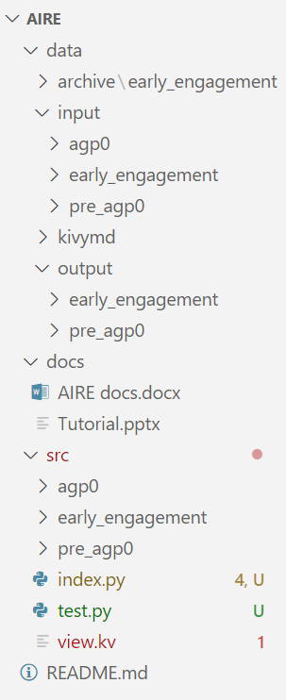

Architecture

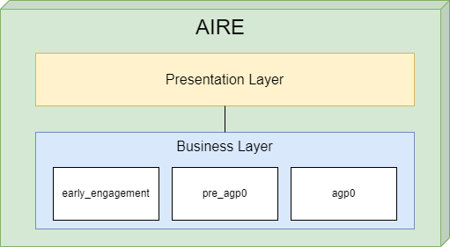

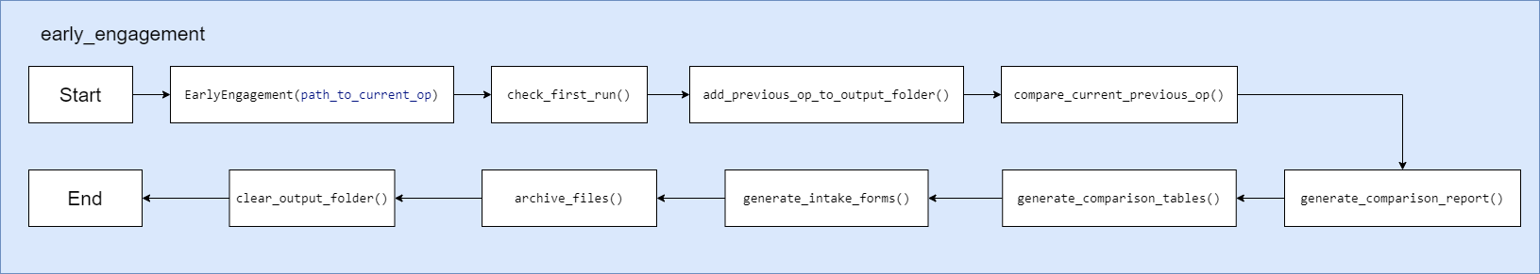

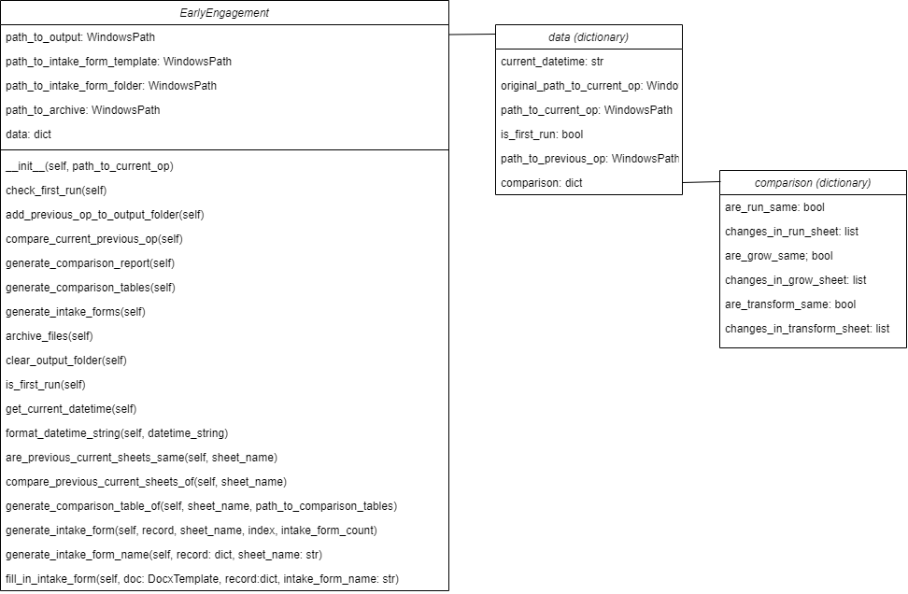

early_engagement(path_to_curr_op)

1. Receives a path to an operational plan file

2. Initializes [data] dictionary variable

3. Put current datetime into [data]

4. Copy the received operational plan file to the output folder

5. Put the path to the operational plan file in the output folder into [data]

check_first_run()

1. Check whether there was a previous run by checking the archive folder

add_previous_op_to_output_folder()

1. Copy the previous operational plan file in the archive folder into the output folder

2. Add the path to the previous operational plan file in the output folder to [data]

compare_current_previous_op()

1. Compare the previous and current operational plans

2. Initializes [comparison] dictionary variable

3. Put comparison results (same or not, changed cell location and values if there is any) into [comparison]

4. Put [comparison] into [data]

generate_comparison_report()

1. Generate a Word Document object

2. Iterate through [data] to put information into the Word Document object

3. Save the Word Document object as a Word file in the output folder.

generate_comparison_tables()

1. Make a copy of the current operational plan file to use it to describe the changed cells

2. If one of the sheets (RUN/GROW/TRANSFORM) are changed, compare the previous and current operational plan files of the changed sheet, highlight the changed cells,and write both previous and current values in the copied file

generate_intake_forms()

1. Generate intake forms of all items in the 3 sheets (RUN/GROW/TRANSFORM) and save them in the output folder

archive_files()

1. Make a zip file of the output folder and put it in the data/archive folder

2. Save the current operational plan file in the data/archive folder for the next run (will be used as a previous operational plan)

clear_output_folder()

1. Delete all the files in the output folder for the next run

Pre-AGP0 module (TBD)